**Course Elements**

Having learnt about [**Usability Principles**](https://play.fresco.me/course/264), let us explore on **Wireframing**.

In this course, you will get to learn the following concepts.

1.Introduction to Wireframing

2.Importance of Wireframes

3.Wireframe vs Mockup vs Prototype

4.Choosing Your Wireframe Style

5.Wireframing Design Principles and Pattern Libraries Guide

**Setting the Context**

**Wireframing is an essential step in product design and development.** If you are creating a new mobile application, website, **wireframes** play a pivotal part in placing the developers, designers, product managers, and others on the same page.

Wireframes can be modified easily and fast to support the iterative and collaborative style of product design and development in agile enterprises and startups. It is for this reason; wireframes are generated in the product design and development process.

*Now, let's walk through the next cards of wireframing.*

**What is a Wireframe?**

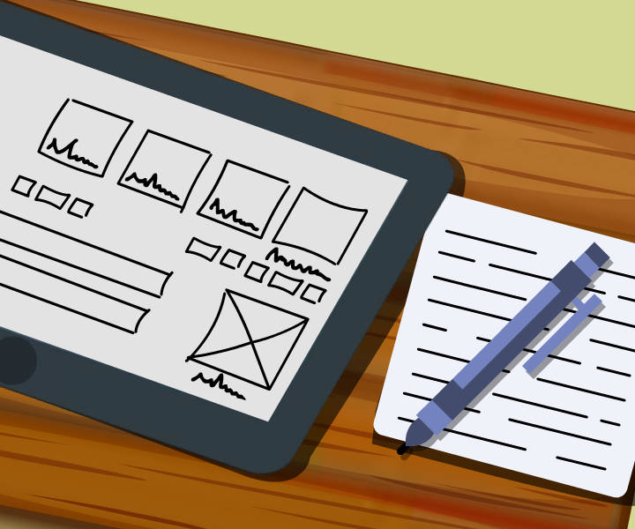  
***A wireframeis a screen blueprint/model of your application/website without any design and coding. It is a crucial element of the interaction design process.***

* It is used to test ideas before you use high-priced design and development resources for your UX project.
* It allows designers and developers to present proposed functions, graphic elements, structure, and content with simple line drawings.
* It is easier to adapt than a concept design.

**What is Wireframing?**

***Wireframing is a process to design an application at the structural level using wireframes.***

# **Wireframing happens early in the project lifecycle.**

**Who Uses Wireframes?**

**Anyone who is involved in the product can use wireframes.** Wireframes are typically used by

* Interaction designers
* Programmers
* Graphic designers
* User experience designers
* Product managers
* Information architects
* Business analysts

**Why Must You Use Wireframes?**

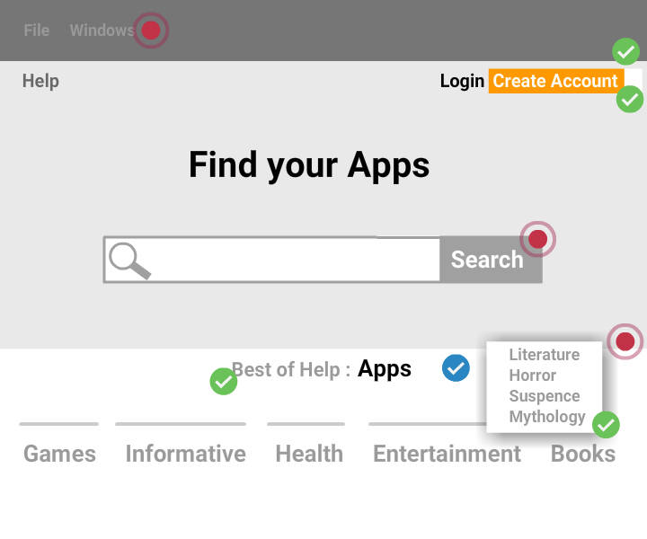

Wireframes are considered to be the **blueprint for design**.

**Wireframes** are intended to connect the **information architecture** (or conceptual structure) to the **visual design** (surface) of a mobile app or website.

They are also the visual representations of an interface, which are used to convey the application details to everyone evenly.

**Why Must You Use Wireframes?**

Ahead of the application development, wireframes provide clarity on the following:

* **Structure** – How will the different parts of the application be put together?
* **Content** – What content will be shown on the application?
* **Informational hierarchy** – How is this content displayed and organized?
* **Functionality** – How will the application's interface work?
* **Behavior** – How will the application behave and interact with the user?

***Wireframes are not intended to represent the graphic elements, visual design, or communicate the identity or brand.***

**Advantages of Wireframing**

* Offers an **early visual** that is useful for reviewing with the client.
* Can be reviewed as an **initial feedback mechanism** for prototype usability testing.
* Ensures the **functionality and page content** are positioned rightly based on business and user requirements.
* Can be **changed easily** than concept designs.
* **Offers confidence** to the UI designer, once users and the client approve the wireframes.

**Associated Inconveniences**

* Some times, clients may find it difficult to understand the concept of the application from wireframes, as the wireframes do not include any account or design for technical implications.
* A designer has to translate the wireframes into a design. Communication is required to support the wireframe, explaining why page elements are placed there.
* When content is added initially, it might not appear to fit in the wireframe layout properly. Because of this, the copywriter and designer may have to work jointly to make this fit suitably.

Nevertheless, wireframes are ideally an **essential** and **'must' to create** step in the design process.

**Wireframes vs Mockups vs Prototypes**

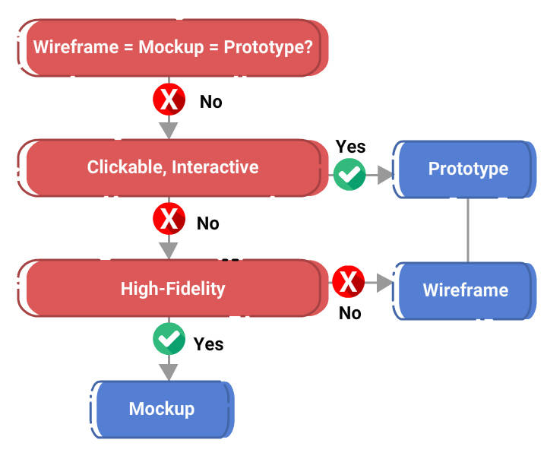

**Usually, most people assume that prototypes, wireframes, and mockups are the same? But in reality, they are different from each other.**

Let’s check the above flowchart to understand the difference separating wireframe, prototype, and mockup.

**Flowchart Explained**

From the flowchart seen in the previous card, you can notice the following traits.

* **Prototypes** are
  + **dynamic**
  + **clickable**
  + **interactive**
* **Wireframes** are
  + **static**,
  + **exhibit low-fidelity**
* **Mockups** are
  + **static**,
  + **exhibit high-fidelity**

***Note****: Design fidelity is the level of functionality and details incorporated into a prototype. Fidelity is of three types: low, mid, and high.*

**Wireframes - a Layout of Gray Boxes**

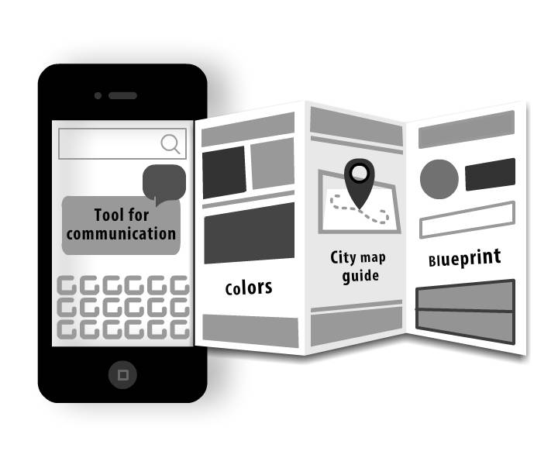

* Wireframes addresses problem-solving aspects.
* They do not focus on looks such as how it functions in various scenarios, or what it can provide users.
* Visual elements must be as minimal as possible.
* **The most used colors are gray, white, and black.**
* For product managers and designers, wireframes:
  + are a mode of communication,
  + visualize the product concept,
  + make it easy to comprehend the concept by team members,
  + drive and progress the discussion,
  + gather helpful feedback instantly.
* Wireframes can be,
  + drawn by hand
  + doodled on whiteboard
  + built using a digital tool.

**Mockup - a Visual Imitation of Product Design**

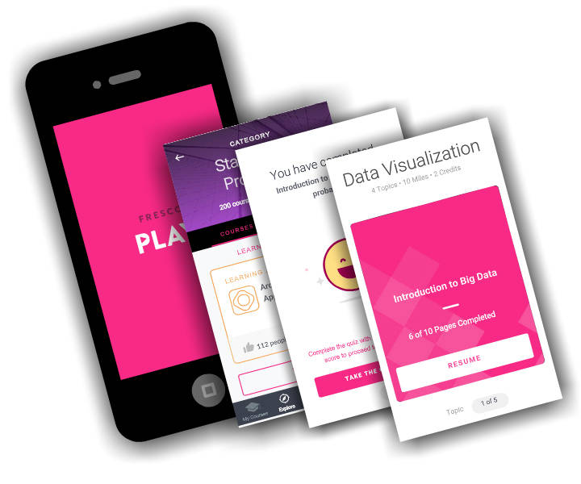

***Mockups render the visual imitation of a product design.***

* In contrast to wireframes, mockups include richer visual elements such as color, visual style, add typography.
* Mockups are not clickable and static.
* They are **pixel perfect**.
* They resemble the look and feel of the final design.
* Mockups target a product's outlook and incorporate high-fidelity visual representation with vibrant visual elements.
* Mockups allow designers to gather the feedback on the visual look of a product instantly.

**Prototype - Interactive and Clickable**



***Prototypes are clickable, so when you click/press a prototype, you will get a response.***

A clickable prototype,

* simulates the interaction between users and the UI in real time.
* enhances the effectiveness of the interaction.
* allows UX designers to test and discover the potential issues in the interaction flow at a prior stage.

**High-Fidelity and Low-Fidelity Prototypes**



# **High-Fidelity Prototype** When numerous **mockup pages** are made as clickable, these mockups can be converted as a prototype. This is known as a high-fidelity prototype.

# **Low-Fidelity Prototype**

When numerous pages of **wireframes** are made as clickable, these wireframes can be converted as a prototype. This is termed as a low-fidelity prototype.

##### ****Choosing Your Wireframe Style****

**Every interaction, graphic, shade, text, and line that a designer adds to a wireframe affects how users interpret and comprehend the product concepts.**

There are many styles available for wireframing, which keeps on evolving with time. Here comes few wireframing styles that you can choose for your project.

##### ****Wireframe Styles****

### Tools and Mediums

* Sketching
* Paper Cutouts
* Stenciling
* Wireframing Software
* Graphic Design Software
* Presentation Software
* Fidelity Levels

##### ****Non-Digital Wireframing Tools****



Here the most commonly used analog/non-digital tools and mediums used for wireframing.

* **Sketching**
* **Blackboarding and Whiteboarding**
* **Stenciling**
* **Paper Cutouts/Paper Prototyping**

Note: There are many more tools available for use and you can choose the best one that suits you.

##### ****Digital Wireframing Tools****



Here the most commonly used digital tools and mediums used for wireframing.

* **Word Processing Software** - Google Docs, Microsoft Word, Apple Pages
* **Presentation Software** - PowerPoint, Google Slides, Prezi, Keynote
* **Graphics Editing Software** - Photoshop, Adobe Illustrator, Sketch
* **Wireframing and Prototyping Software** - Proto.io, Axure, Balsamiq, UXPin, Sketch

Note: There are many more tools available for use and you can choose the best one that suits you.

##### ****Choosing Your Wireframe Style****

### ****Fidelity Levels****

Apart from the mediums and tools in wireframing, you must explore other levels of details that are based on the purpose of a wireframe and the product design process. These are the following fidelity levels that you must consider.

* **Block Diagrams**
* **Grey Boxes**
* **High-Fidelity Text**
* **High-Fidelity Color**
* **High-Fidelity Media**
* **High-Fidelity Interactions**

##### ****Choosing Your Wireframe Style****

### ****Additional Details****

After choosing the right tools and mediums, and the appropriate level of detail, you have to include the finishing touches. Few wireframe details may require description and display interactions. Sometimes, many wireframes may be joined together to display the user flows.

These are a few additional types of wireframes:

* **Basic Wireframes**
* **Annotated Wireframes**
* **Wireframes With User Flows**
* **Interactive and Click-Through Wireframes**

##### ****Importable Libraries****

Use the following importable libraries for choosing your preferred product design patterns.

* [***Patterns by UXPin***](https://studio.uxpin.com/patterns)
* [***Mockups To Go***](https://mockupstogo.net/)

##### ****Standalone Libraries****

Use the following standalone libraries for choosing your preferred product design patterns.

#### Web and Mobile

* [***I Love Wireframes***](https://flickr.com/groups/ilovewireframes)
* [***Wireframe Showcase***](https://wireframeshowcase.com/)
* [***Web Without Words***](https://webwithoutwords.com/)
* [***Wireframes Magazine***](https://wireframes.linowski.ca/tag/wireframe)
* [***Patterntap by Zurb***](https://patterntap.com/)
* [***UX Archive***](https://uxarchive.com/)
* [***Behance***](https://behance.net/search?search=wireframe)
* [***Dribbble***](https://dribbble.com/search?q=wireframe)
* [***Google Image Search***](https://google.com/#q=wireframes)
* [***Pinterest***](https://pinterest.com/search/pins/?q=wireframes)

##### ****Standalone Libraries****

Use the following standalone libraries for choosing your preferred product design patterns.

#### Web Only

* [***UI Patterns***](https://ui-patterns.com/patterns)

**Mobile Only**

* [***Pttrns***](https://pttrns.com/)
* [***Android App Patterns***](https://android-app-patterns.com/)
* [***Inspired UI***](https://inspired-ui.com/)
* [***Mobile Patterns***](https://mobile-patterns.com/)
* [***MobileFrames***](https://moobileframes.tumblr.com/)

##### ****Wireframing - Course Summary****

Finally, you have finished the course on Wireframing. Let's see what you have covered so far.

* Introduction to Wireframing
* Importance of Wireframes
* Comparison of Wireframe, Mockup and Prototype
* Different styles of Wireframes and choosing one
* Wireframing Design Principles and Pattern Libraries Guide

We hope you are now geared up to return to your project and tweak it better by applying your understanding of wireframes.